Pilot Study: Vending Machines at the University of Auckland
Summary
Vending machines are a convenient source of energy-dense nutrient-poor food and beverages. University students spend a significant time on campus; the exposure to a food environment that fails to support healthy food choices may be detrimental to their health. The aim of this pilot study was to audit the nutritional content and cost of food and beverages available from vending machines located within a large urban university campus in New Zealand and to examine the relationship between product availability and sales. Vending machines (n=3) were included in cross-sectional audit of available snacks and beverages purchased and sales were electronically tracked. Nutritional information of each product was then obtained either from the manufacturer’s website, or product nutrition information panels. Food and beverages were then categorised and classified as green, amber, or red using the new National District Health Board’s Healthy Food and Drink Policy. The most common snacks were found to be chocolate/confectionery (37%), followed by potato chips (27%). Sugar sweetened beverages occupy more than four times the vending slots for water. The average portion of beverage vended would be approximately 400mL, contain 622kJ – of which 570kJ would be from sugar (34g). Dairy drinks and 100% fruit juice were most expensive, with sugar-sweetened soft drinks being the cheapest. There was a strong correlation between the availability of food and beverage items and what is purchased (R2 0.96, P<0.05). The majority of snacks and beverages offered are categorised as red and therefore, healthier alternatives should be considered to replace these items in order to improve the food environment.
Aims/Objectives
The aim of this pilot study was to audit the nutritional content and cost of food and beverages available from vending machines located within a large urban university campus in New Zealand and to examine the relationship between product availability and sales.
What did you do?
Vending machines (n=3) were included in cross-sectional audit of available snacks and beverages purchased and sales were electronically tracked. Nutritional information of each product was then obtained either from the manufacturer’s website, or product nutrition information panels. Food and beverages were then categorised and classified as green, amber, or red using the new National District Health Board’s Healthy Food and Drink Policy.
What was the context / background?
There is an increased supply in our food environments of energy-dense nutrient-poor foods and beverages, containing added sugars, fats particularly saturated fats and salt, and this has been a big contributor to development of obesogenic environments that promote weight gain of the population.
Young adults (aged 18–35 y) have a higher intake of energy-dense, nutrient-poor foods and drinks, including sugar-sweetened soft drinks, fried potatoes, meat pies, savory pastries, pizza, crisps, and confectionery, compared with older adults, resulting in an overall poorer diet quality. This age group experiences the highest rates of weight gain across the life course. This theory of weight gain during young adulthood is supported by longitudinal cohort data from both Australia, New Zealand and the United States.
Vending machines have been found to offer convenient access to EDNP snack foods and beverages and are therefore suitable targets for public health interventions.
Vending machines are a convenient source of energy-dense nutrient-poor food and beverages. University students spend a significant time on campus; the exposure to a food environment that fails to support healthy food choices may be detrimental to their health.

How was it organised and who was involved?
Internal / external partnerships

What resources did you need?
Master’s of nutrition and dietetics student conducted the audit and the analysis and the chief investigator statistically analysed all results.

Has it been evaluated? How successful has it been?
Sugar sweetened beverages occupy more than four times the vending slots for water. The average portion of beverage vended would be approximately 400mL, contain 622kJ – of which 570kJ would be from sugar (34g). Dairy drinks and 100% fruit juice were most expensive, with sugar-sweetened soft drinks being the cheapest. The most common snacks were found to be chocolate/confectionery (37%), followed by potato chips (27%). Food sales data showed a strong correlation between the availability of food and beverage items and what is purchased (R² 0.96, P<0.05).
Has this become business as usual / influenced processes in your organisation?
The majority of snacks and beverages offered were categorised as red according to the National Healthy Food and Drink Policy. The majority of vended snacks and approximately half of vended beverages were EDNP options. The majority of vended snacks and approximately half of vended beverages were EDNP options. Given that nutrition interventions that increase the availability of healthy snacks in vending machines have been shown to be effective at improving the nutritional value of the snacks purchased and the knowledge that young adults are susceptible to obesogenic environments, efforts are being made within the university campus to improve the nutritional contents of vending machines.
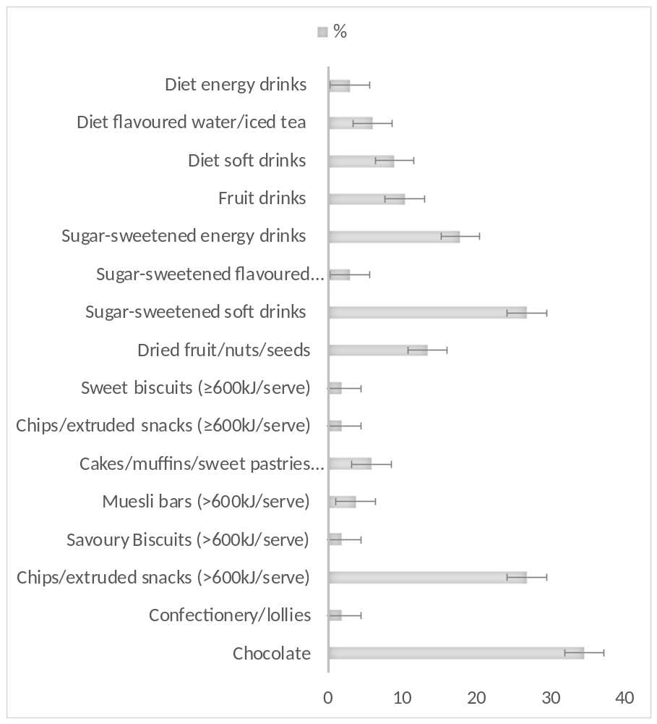

Future Plans
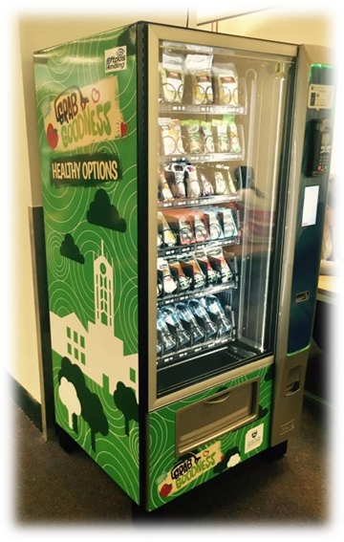
A thorough nutritional analyses of the above Grab Goodness vending machine products have been carried out by the researchers and the products that had a health star rating of 3.5 or greater and met the National Healthy Food and Drink Policy have been added to the new Grab Goodness machine configuration for a university wide roll out.
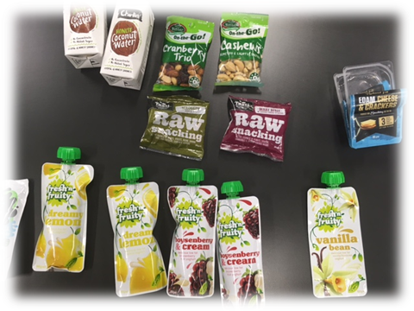

Key Learning Points
This was a baseline evaluation research/project and therefore there were no interventions we could evaluate. However, we are currently in the process of evaluating the new healthy grab goodness vending machines and how they affect the purchasing behaviour of staff and students within a tertiary education setting when directly compared with the food purchasing from normal vending machines containing less-healthier choices.
Thematic Categories
Method |  | Topic |  | Population Group
Campaign / Event |  | Alcohol / Substance Misuse |  | Staff
Pedagogy Related |  | Built or Social Environment |  | Students
Project |  | Food / Healthy Eating |  | Wider Community
Policy / Procedure |  | Emotional / Mental Health / Sleep |  | Other- PleaseState
Whole System Approach |  | Physical Activity / Active Transport
External Partnership |  | LGBTIQA
Research |  | STIs / Contraception
Baseline Evaluation |  | Natural Environment
Other- PleaseState |  | Tobacco
 |  | Healthy Relationships
 |  | Social Connectedness
 |  | Other- PleaseState
Your Contact Details
Name of Organisation | The University of Auckland
Contact Name / Details | Dr Rajshri Roy, PhD
Version 1 08-12-15. Thanks to Healthy Universities UK for allowing us to modify their case study form.

