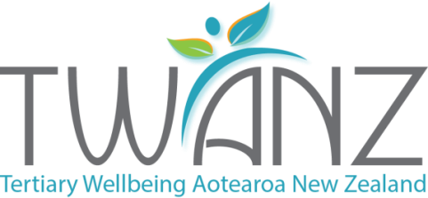

TRANSLATING THE OKANAGAN CHARTER
FOR PRACTICE IN AOTEAROA NEW ZEALAND TERTIARY EDUCATION SETTINGS
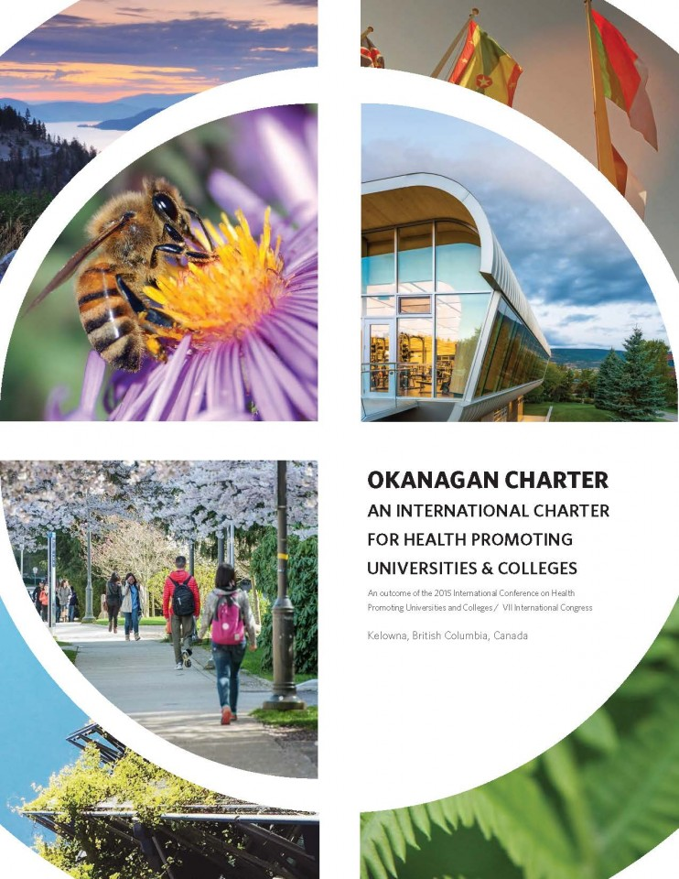

Whakataukī
Nā tō rourou, nā taku rourou ka ora ai te iwi.
With your food basket and my food basket, our people will flourish.

About the authors
This guide was prepared by the Tertiary Wellbeing Aotearoa New Zealand (TWANZ) executive group. The executive is responsible for coordinating the TWANZ national network which aims to support local, national and international collaboration and initiatives between the health promotion and tertiary education sectors to increase the health and wellbeing of tertiary students and staff. More information is available at www.twanz.ac.nz.
Anna Tonks Regional Public Health, Capital & Coast, Hutt Valley and Wairarapa District Health Boards
Anna Thorpe Community and Public Health, Canterbury District Health Board
Catherine Jeffries Ministry of Education
Craig Waterworth Massey University Wellington
Hannah Molloy Regional Public Health, Capital & Coast, Hutt Valley and Wairarapa District Health Boards
Imogen Holmstead-Scott Massey University
Jude West Victoria University
Karen Hicks University of Auckland/Unitec
Kylie Ryan University of Auckland
Rose Reynolds University of Canterbury
Tessa Burgess Victoria University

Acknowledgements
The TWANZ executive group would like to acknowledge the contributions from individuals and organisations that have provided support, academic expertise and cultural advice. This was critical to the development of the guide.

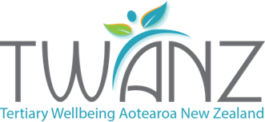
Executive Summary
This translation guide is designed as a tool for health promoters, policy makers, health and safety staff, cultural and student support staff, student bodies and management in tertiary institutions to assist with understanding and applying the 2015 international Okanagan Charter
http://internationalhealthycampuses2015.sites.olt.ubc.ca/files/2016/01/Okanagan-Charter-January13v2.pdf on campuses in Aotearoa New Zealand.
The Okanagan Charter makes a valuable contribution to health promotion practice in higher education settings, with its set of guiding principles and priority actions. This includes Aotearoa New Zealand, where the Charter’s principles and calls to action can be applied to national tertiary needs and approaches. Māori wellbeing frameworks, Te Pae Mahutonga and Te Whare Tapa Whā, comfortably sit alongside the Okanagan Charter. The Okanagan Charter is viewed as a useful and flexible framework to further develop strategic planning, coordination and integration in tertiary settings.
This guide provides a practical guide for how to translate the Okanagan Charter ‘Calls to Action’ into practice for tertiary education settings in Aotearoa New Zealand, reflecting its unique settings, knowledge and populations. Its purpose is to support the implementation of health promotion activities and assist the integration of wellbeing into campus initiatives, policies and teaching practices, to assist in reducing inequalities and preventing ill health.
The purpose of this translation guide is to raise awareness and inspire action aligned with the Okanagan Charter and its Calls to Action within higher education settings in Aotearoa New Zealand. It is hoped that it will be a resource for tertiary institutions, as a source of information and vision to assist with efforts to develop health promoting campuses in Aotearoa New Zealand, leading to health promotion action and collaborations locally and globally.

The Okanagan Charter and the Aotearoa New Zealand context
The potential of promoting health and wellbeing within tertiary education settings is being realised locally and globally. In June 2015, tertiary education and health promotion delegates from 45 countries (including Aotearoa New Zealand) collaborated to develop the Okanagan Charter – An International Charter for Health Promoting Universities and Colleges. The Okanagan Charter provides a framework for tertiary institutions to embed health and wellbeing into all policies, practice and collaborations.
The importance of Aotearoa as a bicultural and multicultural nation is well recognised in the health and wellbeing sector. The Te Tiriti o Waitangi, as the founding constitutional document in Aotearoa New Zealand, and Māori approaches to health promotion are considered in this guide applying the Okanagan Charter. Purposefully supporting student and staff wellbeing in tertiary settings helps with recruitment, retention, engagement and achievement (Bevan, 2010; Bradley & Greene, 2013); resulting in personal, organisational, community and economic gains. Both students and staff perform at a higher level, enjoy better health and report greater happiness when health and wellbeing promotion is activated in education settings (Oades et al., 2011).
All action areas of the Okanagan Charter are designed to overlap in practice and be used simultaneously, as part of an interconnected approach. The approaches and actions described in this guide are not prescriptive, but rather form integrated guidelines on which to build wellbeing strategy and action plans within tertiary education settings. It is recommended that health and wellbeing promotion have a strategic direction; be coordinated; action orientated; supported by senior management; and be developed in partnership with affected students and staff. To assist local tertiary institutions to practically apply the Okanagan Charter, each of the Charter’s action points has been interpreted using the lens of Te Pae Mahutonga and Te Whare Tapa Whā. Under each, an aspirational statement, guiding questions, examples of practice and measurement of success have been developed.
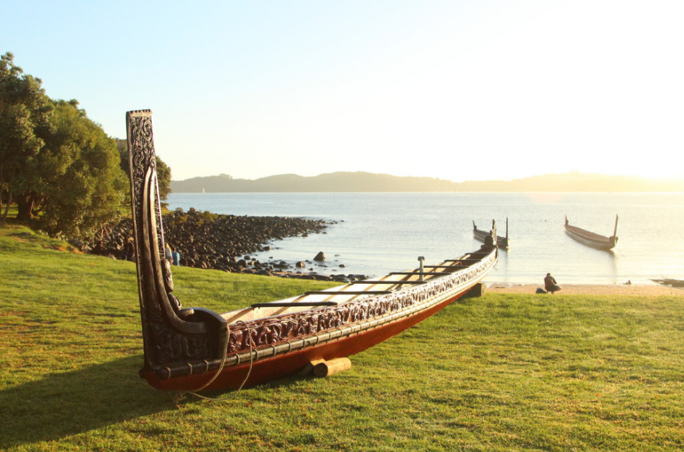

Okanagan Charter
Purpose
- Guide and inspire action by providing a framework that reflects the latest concepts, processes and principles relevant to the Health Promoting Universities and Colleges movement, building upon advances since the 2005 Edmonton Charter
- Generate dialogue and research that expands local, regional, national and international networks and accelerates action on, off and between campuses
- Mobilise international, cross-sector action for the integration of health in all policies and practices, thus advancing the continued development of health promoting universities and colleges

Two calls to action with eight key action areas
- Embed health into all aspects of campus culture, across the administration, operations and academic mandates
  - Embed health in all campus policies
  - Create supportive campus environments
  - Generate thriving communities and a culture of wellbeing
  - Support personal development
  - Create or re-orient campus services

- Lead health promotion action and collaboration locally and globally
Integrate health, wellbeing and sustainability in multiple disciplines to develop change makers
  - Advance research, teaching and training for health promotion knowledge and action
  - Lead and partner towards local and global action for health

Eight key principles for action
- Use settings and whole systems approaches
- Ensure comprehensive and campus-wide approaches
- Use participatory approaches and engage the voice of students and others
- Develop trans-disciplinary collaborations and cross-sector partnerships
- Promote research, innovation and evidence-informed action
- Build on strengths
- Value local and indigenous communities, contexts and priorities
- Act on an existing universal responsibility
Aotearoa New Zealand wellbeing frameworks
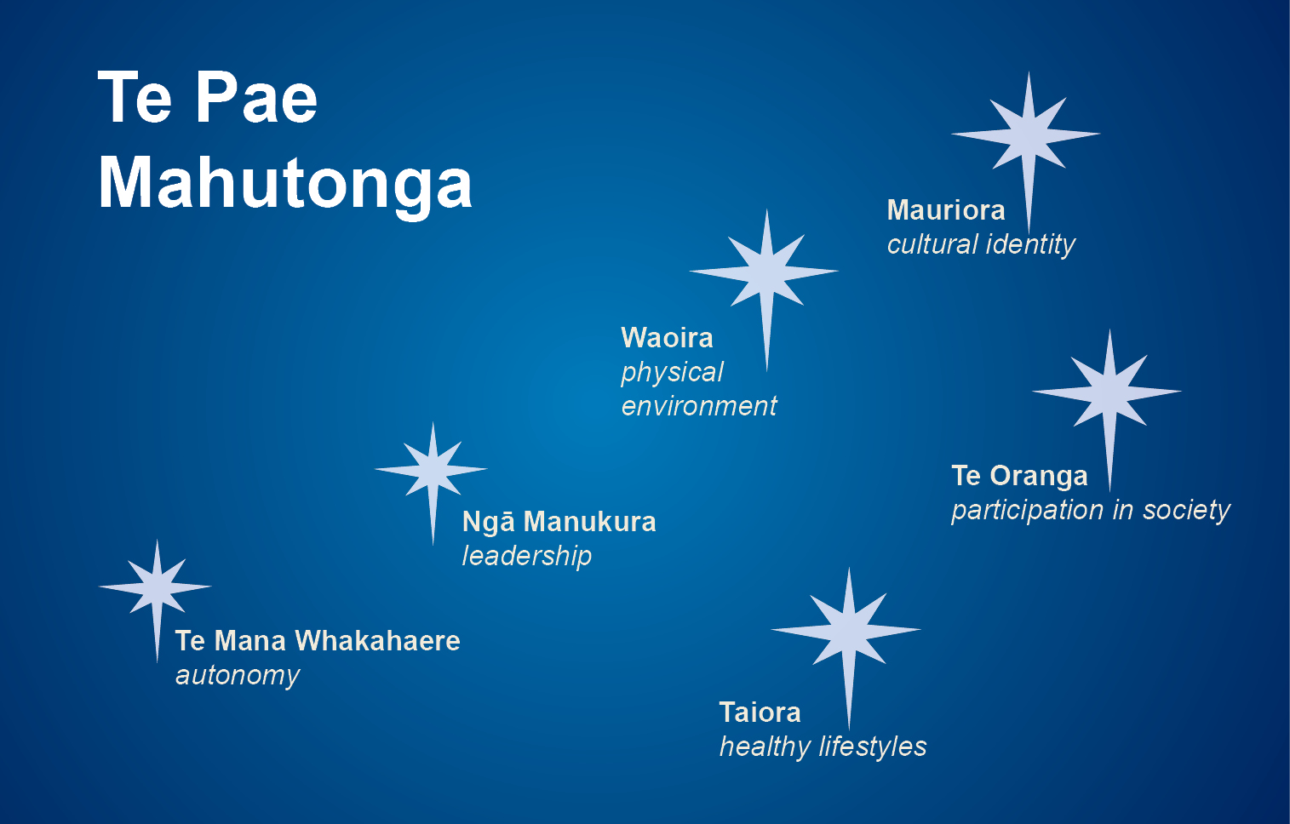
To apply the Okanagan Charter in an Aotearoa New Zealand context, this guide used Te Pae Mahutonga (Durie, 1999) and Te Whare Tapa Whā (Durie, 1982) as interpretative lenses. These two models can be used when working with people of all cultures. The key principles and concepts from these models were considered and incorporated when interpreting and analysing the Okanagan Charter’s ‘Calls to Action’. This guide also incorporates Te Tiriti o Waitangi understanding of hauora and the principles of protection, partnership and participation (Health Promotion Forum of New Zealand, 2002).
Te Pae Mahutonga is depicted using the Southern Cross constellation where the four stars provide the foundations of health promotion; waiora (physical environments), mauriora (cultural identity), te oranga (participation in society) and toiora (healthy lifestyles). The guiding stars, acting as prerequisites for health promotion, are ngā manukura (leadership) and te mana whakahaere (autonomy) (Durie, 1999).

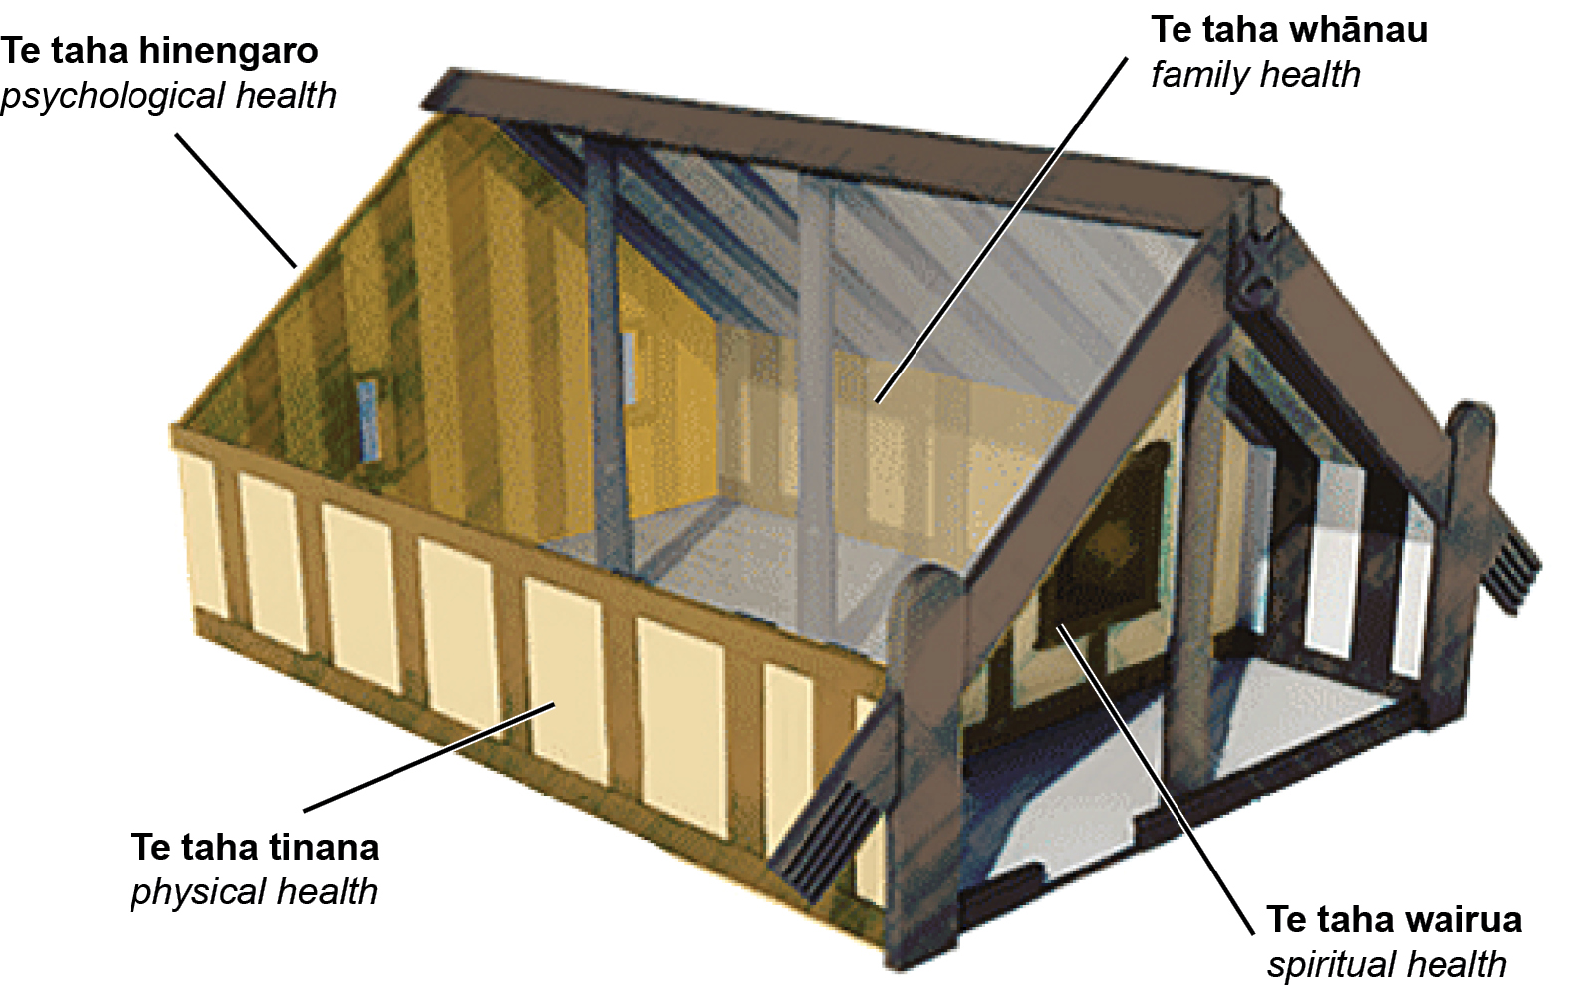
Te Whare Tapa Whā is depicted as a house, with the four walls representing four dimensions of wellbeing. These are taha tinana (physical health), taha wairua (spiritual health), taha whānau (family/social health), and taha hinengaro (emotional health). All walls must be strong for positive wellbeing (Durie, 1982).

Call to Action 1: Embed health into all aspects of campus culture, across the administration, operations and academic mandates
  - Embed health in all campus policies
Review, create and coordinate campus policies and practices with attention to health, wellbeing and sustainability, so that all planning and decision making takes account of and supports the flourishing of people, campuses, communities and our planet.

Aotearoa New Zealand context
This action area connects strongly with Te Oranga and Te Taha Wairua in Te Pae Mahutonga. All tertiary institutions have policies and practices that support positive and sustainable development of people, culture and the environment. Campus policies and practices reflect a commitment to Te Tiriti o Waitangi and are coordinated to achieve equity. Campus policies which are mana enhancing and reflective of the diverse realities of all students are promoted. All student and staff groups have culturally affirming opportunities to engage in the development, implementation and review of policy. Māori and Pasifika staff and students and those from diverse backgrounds have input into decision-making, policy development implementation regarding health, wellbeing and sustainability.
Guiding questions
- Does your institution have a health and wellbeing policy?
- Does policy incorporate holistic models of health promotion (e.g. Te Whare Tapa Whā or Te Pae Mahutonga) that students and staff engage can engage in culturally affirming ways?
- How have your staff and students contributed to policy development, including diverse groups?
- How do you embed health, wellbeing and sustainability policies/strategies throughout departments?
- What are the health and wellbeing outcomes resulting from the proposed policy?
- Do policies incorporate the latest evidence?

Opportunities for action
- Te Tiriti o Waitangi is visible in wellbeing policy
- Tertiary institutions have policies to support health and wellbeing e.g. wellbeing and sustainability policies
- Diverse voices in policy development and review e.g. Māori, Pasifika, international, LGBTIQA+, youth and mature students and those with disabilities
- Policy development incorporates student and staff consultation, co-design and user-led approaches
- Connections between policies are clear and cited in relevant policies
- Pedagogical practices incorporate wellbeing promotion

Measuring success
- Policies have regular review dates
- Policy reviews include health and wellbeing promotion and Te Tiriti o Waitangi application
- Students and staff demonstrate awareness of campus policies and are informed of regular opportunities to have input into policy reviews
- Policies address and demonstrate reductions in inequality, by ethnicity, gender, sexuality, sex, disability and other demographic indicators
- Evidence of interconnectedness between policies
- Wellbeing working groups address policy and resulting practice e.g. study groups, diversity committee

1.2 Create supportive campus environments
Enhance the campus environment as a living laboratory, identifying opportunities to study and support health and wellbeing, as well as sustainability and resilience in the built, natural, social, economic, cultural, academic, organisational and learning environments.

Aotearoa New Zealand context
This action area connects strongly with Te Pae Mahutonga’s Waiora and Te Oranga, while considering all holistic aspects of Te Whare Tapa Whā and an appreciation of connection to whenua. A supportive campus environment is a place where all students and staff feel included, engaged and valued. There is a focus on enhancing social connectedness, addressing the determinants of health and encouraging participation in all aspects of the tertiary education experience. Tertiary campuses are environments where all students and staff are supported to reach their full academic, social, health and wellbeing potential. All campus environments (built, natural, social, economic, cultural, academic, organisational and learning) provide opportunities for staff and students to connect, affirm identity and foster resilience.
Guiding questions
- How do students and staff experience your campus?
- What is being done to reduce barriers and identify opportunities to ensure a supportive campus for a diverse range of people?
- How can your campus environment be adapted to facilitate academic success, social connectedness, health and wellbeing, and positively influence the determinants of wellbeing?
- How do your campus environments ensure positive outcomes are sustained?
Opportunities for action
- Accessible and appropriate services address study, financial, housing, physical and wellbeing needs
- Universal access to the natural and built environments, which encourage physical activity and mindfulness
- Smokefree campus with cessation services
- Safe, quiet spaces for personal expression and time out, including Muslim prayer rooms and chapels
- All gender toilets
- Activities celebrate cultural diversity
- Online environments support distance students to achieve
- Access to a campus marae
- Provision of Pasifika study spaces

Measuring success
- Students and staff surveys on feelings of safety and security around the campus
- Students and staff surveys demonstrate engagement with and enjoyment of the campus environment
- Audits assess barriers and opportunities to being a supportive campus community
- A campus wide sustainability plan is enacted
- Review of diverse student enrolment, engagement, supports and achievement
- Review of diverse staff recruitment, engagement, supports and achievement

1.3 Generate thriving communities and a culture of wellbeing
Be proactive and intentional in creating empowered, connected and resilient campus communities that foster an ethic of care, compassion, collaboration and community action.

Aotearoa New Zealand context
This area connects strongly with Te Oranga, Mauriora and Te Taha Whānau in Te Pae Mahutonga. Tertiary campuses are settings for developing student and staff potential in education, health and wellbeing. A sustainable culture of wellbeing in learning environments recognises and celebrates the diversity of staff and students. The rights of tangata whenua are respected and demonstrated through culturally appropriate, accessible and affirming services that promote wellbeing and connection. Students and staff from diverse backgrounds will be encouraged and enabled to start initiatives and seek solutions to foster a culture of wellbeing. By empowering these populations a sense of ownership, collectivity and self-determination is created.
Guiding questions
- What are the values, realities and aspirations of your students and campus community?
- How do your students and staff identify regarding ethnicity, culture, disability, gender identity, sexual orientation?
- How does your campus foster collaboration and community action – internally and externally - to encourage a culture of wellbeing?
- Are strength based approaches, such as positive education and cooperative learning used in curriculum development and education delivery?
- Are broader cultural models considered when appropriate, such as Fonofale for Pasifika, or Confucianism for Asian cultures?
Opportunities for action
- Interdisciplinary approach to address priority issues e.g. promoting mental wellbeing, reducing alcohol harm and sexual violence on campus
- Low cost accessible healthcare options, including rongoā Māori and holistic approaches
- Strong reciprocal relationship with local iwi and tangata whenua
- Campus infrastructure supports wellbeing e.g. healthy foods, sun shades, bike sheds, showers, mental health first aid training, ethical bystander training
- Community action fund available for staff and students

Measuring success
- Increase in staff and student engagement with wellbeing activities and programmes
- Evidence of interdisciplinary staff collaboration
- Review of collaborative partnerships with local external communities
- Health events demonstrate linkages to on-going programmes that support behaviour/cultural change
- Students and staff express strong levels of engagement and connection with the tertiary organisation
- Alcohol harm reduction is regularly monitored

Aotearoa New Zealand context
1.4 Support personal development
Develop and create opportunities to build student, staff and faculty resilience, competence, personal capacity and life enhancing skills – and so support them to thrive and achieve their full potential and become engaged local and global citizens while respecting the environment.
This area connects strongly with Toiora, Te Taha Tinana and Te Taha Hinengaro in Te Pae Mahutonga and all aspects of Te Whare tapa Whā. Meaningful personal development opportunities are provided and are easily accessible for both students and staff. Individuals are supported to develop personal skills and strengths that increase their own and others wellbeing, resilience, competencies and achievements. Targeted efforts and resources are dedicated for Māori, Pasifika and vulnerable populations (e.g. international students, students with chronic health conditions). Diversity is acknowledged, affirmed and celebrated, leading to stronger, more resilient and culturally safe staff and students. Supporting healthy lifestyles for students and staff is a priority. Institutions provide multiple and diverse pathways to assist individuals and groups to positively contribute at campus, locally, nationally and internationally, in order to build skills, personal capacity and encourage wider participation.
Guiding questions
- What meaningful, appropriate, on-going personal development opportunities exist on campus?
- Do your staff demonstrate cultural safety with students?
- What cultural competence development opportunities exist for staff and students?
- How does your campus support personal wellbeing for both students and staff?
- What barriers exist for the range of staff to take part in professional development?
- How do your students and staff know about and use community resources and services?
Opportunities for action
- Range of mentoring programmes and peer education
- Health education connects with health initiatives
- Pedagogy encourages personal growth
- Access to healthy environments on campus e.g. free gyms, recreational services, outdoor exercise stations, mindfulness zones
- Te Reo Māori classes available for all students and staff
- Work with student unions and club networks
- Consistency with external health organisations and agencies

Measuring success
- Personal development plans for all staff
- Use of periodic quantitative wellbeing measures
- Students state that they feel culturally safe, staff state that they feel culturally competent
- Training is available and well utilised in relation to Māori kaupapa and tikanga
- Training and mentoring opportunities for staff and students on identified issues

Aotearoa New Zealand context
1.5 Create or reorient campus services
Coordinate and design campus services to support equitable access, enhance health and wellbeing, optimise human and ecosystem potential and promote a supportive organisational culture.
This area connects strongly with Toiora, Waiora and Te Taha Whānau of Te Pae Mahutonga. All tertiary services and infrastructure - wellbeing, education, recreation, operational - are aligned to positively promote wellbeing and there is a focus on enhancing access, the promotion of wellbeing, and the prevention of illness. Campus services are inclusive and oriented to improve access socially, economically, culturally and geographically. Services are well integrated on campus, health and wellbeing are holistically interpreted, and are sufficiently resourced to deliver health and wellbeing promotion activities. Campus services are designed to optimise the education, health, wellbeing, social and economic benefits a tertiary institution can generate for individuals and the community. Campus services are designed and coordinated to be flexible and reflective, to meet the needs of diverse campus populations.
Guiding questions
- How do your staff and students participate in the design of services?
- Do students and staff meaningfully participate and lead in the running of services?
- What is the balance between prevention and intervention services on your campus?
- How is equality promoted and discrimination, bullying and harassment discouraged and addressed?
- Who are your internal and external partners promoting wellbeing on campus?
- Is the Public Health Association Code of Ethical Principles utilised for health promotion practice?

Opportunities for action
- Coordinated wrap-around services and student Youth One Stop Shops
- Occupational health services for staff
- Subsidies for students – health, gym, public transport, events, libraries
- Environment friendly services e.g. recycling stations, compost, vegetable gardens and green spaces
- Campus infrastructure aligns with health promotion activities, e.g. no cigarettes or alcohol sold, limiting sugary drinks, drinking water widely and freely available
- Campus hostels employ proactive alcohol policies with a harm minimisation focus
- Campus services coordinate with external sexual assault and violence services for intervention and prevention
- Develop an understanding of health and wellbeing within campus services

Guiding Questions
- What opportunities exist for students and staff to have meaningful participation and take on leadership roles in the development and running of services?
- How can staff and students participate in the design of services?
- Who can you partner with to ensure your service is contributing to the promotion of sustainable wellbeing?
- What is the balance between the provision of intervention and prevention services on campus?
- Are processes in place to promote equality and address and discourage discrimination, bullying or harassment?
- Is the Public Health Association code of ethical principles being utilised for health promotion practice?

Measuring success
- Systematic review of all services considering use, access, barriers, user experience and effectiveness
- Services and staffing are representative of the student populations.
- Evidence of preventative and responsive approaches supporting individual and community wellbeing.
- Evidence that the campus provides safe spaces and opportunities for students and staff to express, celebrate and share their culture and aspirations
- Evidence that the campus has a strong, reciprocal relationship with local iwi, rūnanga, marae and kura

Call to Action 2: Lead health promotion action collaboration locally and globally
2.1 Integrate health, wellbeing and sustainability in multiple disciplines to develop change agents
Use cross-cutting approaches to embed an understanding and commitment to health, wellbeing and sustainability across all disciplines and curricula, thus ensuring the development of future citizens with the capacity to act as agents for health promoting change beyond campuses.

Aotearoa New Zealand context
This area connects strongly with Te Mana Whakahaere and Ngā Manukura, the two pointers of Te Pae Mahutonga. Health, wellbeing, sustainability and cultural competence are integrated across the institution and curriculum to develop change agents for health and wellbeing promotion activity. Individual roles, formal and informal committees assist in coordinating health and wellbeing promotion activities. Active multidisciplinary and interdisciplinary partnerships, including staff, students and those from diverse backgrounds are promoted across campus to progress combined health, wellbeing and sustainability priorities across all disciplines and curriculum. These priorities and processes are well coordinated across all campuses and are supported by senior level positions. External collaborations between departments with iwi, hāpu and other organisations are encouraged.
Guiding questions
- How is the senior leadership team resourcing and supporting health and wellbeing promotion action?
- How do you integrate and embed health, wellbeing and sustainability into best teaching practice?
- How do you develop and sustain staff and student leadership in health, wellbeing and sustainability on campus?
- Is there collaboration between disciplines, departments, students, staff and external organisations?
Opportunities for action
- Senior leadership team support and resourcing for health and wellbeing promotion
- Formal positions supported to advance wellbeing e.g. Wellbeing Coordinator position employed at a senior level
- Development of a campus wide Health and Wellbeing Strategy, Action Plan and Wellbeing Committee
- Health, wellbeing and sustainability champions lead priority projects on campus
- Sustainability and Health and Safety activities and staff work collaboratively with health promotion activity and staff
- Student and staff involvement in priority public health campaigns e.g. prevention of intimate partner violence

Measuring success
- Regular student and staff surveys about health and wellbeing needs and priorities
- Evaluations of health, wellbeing and sustainability initiatives on campus
- Regular reporting of collaborations between departments and services internally and externally
- Review embedding of policies and strategies related to health, wellbeing and sustainability
- Evidence of cross -sector and cross-discipline practice based on shared knowledge and purpose
- Evidence of institutional wide support for health and wellbeing initiatives

Aotearoa New Zealand context
2.2 Advance research, teaching and training for health promotion knowledge and action
Contribute to health promoting knowledge production, application, standard setting and evaluation that advance multi-disciplinary and trans-disciplinary research agendas relevant to real world outcomes, and also, ensure training, learning, teaching and knowledge exchange that will benefit the future wellbeing of our communities, societies and planet.
This area connects strongly with Te Mana Whakahaere of Te Pae Mahutonga. Health and wellbeing, including Māori and community wellbeing, and global issues are well integrated into curriculum and research across departments, including knowledge around environmental protection and waiora. A coordinated institutional plan is developed to incorporate and embed health, wellbeing and sustainability into research and the curriculum. Innovation in health promotion learning, teaching and research are valued. Multidisciplinary and transdisciplinary research collaborations on health, wellbeing and sustainability issues are encouraged and communicated. Partnerships with other agencies and communities are developed to progress health promotion knowledge and research.

Guiding questions
- How do you embed health, wellbeing and sustainability into the curriculum across departments?
- How do you facilitate innovative, collaborative, multi-disciplinary research?
- How do you utilise the resources and skills within your institution to advance research and teaching in health, wellbeing and sustainability?
- How do you support and promote Kaupapa Māori teaching, learning and research on campus?
- How do you provide opportunities for students to apply their knowledge to improve campus health, wellbeing and sustainability?
- Are staff undertaking health promotion trained and developed using the Health Promotion Forum competency framework?
Measuring success
- Curricula encompasses health, wellbeing and sustainability where possible
- Health and wellbeing promotion strategies and action on campus are driven by evidence and research
- Evaluate Māori health and wellbeing promotion in the curriculum, and support for Māori research development
- Secure funding for health, wellbeing and sustainability research
- Review how campus and community is informed of health, wellbeing and sustainability issues e.g. website, public lectures
- Research outputs assessed on health promotion and use of impact, process and outcome measures
Opportunities for action
- Māori, Pasifika and generic health promotion papers are offered
- Māori kaupapa and tikanga training on campus
- Positive psychology and education is used in pedagogy
- Living laboratory and action research methodologies promoted for campus health development
- Scholarships for students and staff support for health promotion practicums, internships and research
- Teaching and learning services are available for students and staff and tailored to meet the needs of Māori and Pasifika
Aotearoa New Zealand context
2.3 Lead and partner towards local and global action for health promotion
Build and support inspiring and effective relationships and collaborations on and off campus to develop, harness and mobilize knowledge and action for health promotion locally and globally.

This area connects strongly with Ngā Manukura of Te Pae Mahutonga. Tertiary institutions are well placed to lead local and global action for positive change in health promotion. Relationships, collaborations and partnerships with external stakeholders help drive participation and change on campus, the local community and wider society. Strong management and academic leadership support local and global action around health, wellbeing and sustainability. Health and wellbeing initiatives are showcased for a fairer and safer world. Staff and students are actively encouraged towards health and wellbeing promotion action linking campus learning and global world issues. Building student vision and voice into health, wellbeing and sustainability action on and beyond campus supports long term understanding and skills. Established and formalised partnerships with Māori and Māori health promotion providers aid the promotion of Māori priorities for action on and off campus.
Guiding questions
- How do you build relationships locally and globally to activate health, wellbeing and sustainability?
- How do you transition from conversations about health, wellbeing and sustainability into action?
- How do you build a health promotion movement on campus?
- How can senior management become engaged to be health and wellbeing champions and change makers on campus?
- How do you promote awareness of local and global action to students, staff and the public?
- How do your staff and students engage with and contribute to the health promotion evidence base?

Opportunities for action
- Develop campus wellbeing working groups e.g. staff wellbeing
- Working collaborations with individuals and organisations off campus e.g. climate change
- Partner with networks and agencies to share resources, build knowledge and collaborate on relevant health promotion projects e.g. TWANZ, South Island Tertiary Forum, NZUSA, ANZSSA, AQA, TEC, TEU, I-PEN, NZAPP, ISANA, Ako Aotearoa, HPA, PHA, HPF, ISCN, Worksafe
- Increase the institutional profile externally by sharing good practice initiatives e.g. website, social media
- Community volunteering / involvement is incorporated into student assessments to encourage ‘good citizenship’

Measuring success
- Engage the Senior Leadership Team to formally adopt the Okanagan Charter
- Review and stocktake of community and organisational relationships and collaborations to promote health, wellbeing and sustainability actions
- Wellbeing and Sustainability Committees established with terms of reference and action plans
- Evidence of diverse representatives on campus health, wellbeing and sustainability groups
- Number of staff and students that are members of the TWANZ network
Resources and links
Tertiary institutions: North Island
- NorthTec http://www.northtec.ac.nz/
- University of Auckland https://www.auckland.ac.nz/
- Auckland University of Technology (AUT) http://www.aut.ac.nz/
- Unitec Institute of Technology http://www.unitec.ac.nz/
- Manukau Institute of Technology (MIT) https://www.manukau.ac.nz/
- Auckland Institute of Studies NZ http://www.ais.ac.nz/
- University of Waikato http://www.waikato.ac.nz/
- Waikato Institute of Technology (WINTEC) https://www.wintec.ac.nz/
- Eastern Institute of Technology (EIT) http://www.eit.ac.nz/
- Bay of Plenty Polytechnic (Toi Ohomai) https://www.boppoly.ac.nz/
- Massey University http://www.massey.ac.nz/
- Universal College of Learning (UCOL) - https://www.ucol.ac.nz/about-ucol
- International Pacific College (Palmerston North) http://www.ipu.ac.nz
- Western Institute of Technology at Taranaki (WITT) http://www.witt.ac.nz/
- Victoria University http://www.victoria.ac.nz/
- WelTec http://www.weltec.ac.nz/
- Whitireia Polytechnic http://www.whitireia.ac.nz/

Tertiary institutions: South Island
- Nelson Marlborough Institute of Technology https://www.nmit.ac.nz/
- Ara Institute of Canterbury http://www.ara.ac.nz/
- University of Canterbury http://www.canterbury.ac.nz/
- Lincoln University http://www.lincoln.ac.nz/
- Tai Poutini Polytechnic https://tpp.ac.nz/
- Otago Polytechnic http://www.op.ac.nz/
- University of Otago http://www.otago.ac.nz/
- Southern Institute of Technology https://www.sit.ac.nz/

Wānanga
- Te Wānanga o Aotearoa https://www.twoa.ac.nz/
- Te Whare Wānanga o Awanuiārangi http://www.wananga.ac.nz/
- Te Wānanga o Raukawa, http://www.wananga.com/

Other key organisations
- Universities New Zealand http://www.universitiesnz.ac.nz/
- Ako Aotearoa National Centre of Teaching and Learning in New Zealand https://akoaotearoa.ac.nz/
- Tertiary Education Commission (TEC) http://www.tec.govt.nz/
- New Zealand Qualifications Authority (NZQA) http://www.nzqa.govt.nz/
- Academic Quality Agency (AQA) http://www.aqa.ac.nz/
- Tertiary Education Union (TEU) http://teu.ac.nz/
- National Student Union Association (NZUSA) http://www.students.org.nz/
- UniQ (Queer Students Association at NZ tertiary institutions) websites in larger tertiary institutions
- Ministry of Education http://www.education.govt.nz/
- Ministry of Health https://www.health.govt.nz/
- Health Promotion Agency (HPA) http://www.hpa.org.nz/

Higher education networks
- Achieve – Post secondary education disability network http://www.achieve.org.nz/
- The Australian and New Zealand Student Services Association (ANZSSA) http://www.anzssa2016.com/about-anzssa.html
- Healthy Universities UK www.healthyuniversities.ac.uk
- International Sustainable Campus Network http://www.international-sustainable-campus-network.org/
- Regeneration Network (2010) - Sustainability in the tertiary sector http://www.regeneration.org.nz/Sustainability-in-the-Tertiary-Sector.pdf
- South Island Tertiary Forum www.cph.co.nz
- Sustainable Tertiary Education New Zealand https://sites.google.com/site/strongsustainability/projects/stenz-1
- Tertiary Wellbeing Aotearoa New Zealand (TWANZ) http://www.twanz.ac.nz
- Universities New Zealand http://www.universitiesnz.ac.nz/

Health promotion models
- Fonofale Model of Health (2001) http://www.hauora.co.nz/resources/Fonofalemodelexplanation.pdf
- Fonua Model for Pacific Health Promotion (2007) http://www.hauora.co.nz/resources/22ndJan2.pdf
- Health Promotion Forum of New Zealand Competencies http://www.hauora.co.nz/assets/files/Resources/Health%20Promotion%20Competencies%20%20Final%20-%202012.pdf
- Okanagan Charter: An International Charter for Health Promoting Universities and Colleges (2015) http://internationalhealthycampuses2015.sites.olt.ubc.ca/files/2016/01/Okanagan-Charter-January13v2.pdf
- Ottawa Charter for Health Promotion (1986) http://www.who.int/healthpromotion/conferences/previous/ottawa/en/
- Te Pae Mahutonga (1999) http://www.hauora.co.nz/resources/tepaemahutongatxtvers.pdf http://www.health.govt.nz/our-work/populations/maori-health/maori-health-models/maori-health-models-te-pae-mahutonga
- Te Ture Whakaruruhau: Code of ethical principles for public health https://www.hiirc.org.nz/page/35699/te-ture-whakaruruhau-code-of-ethical-principles/?tab=2616&contentType=451&section=8959Te Whare Tapa Whā (1982) http://www.health.govt.nz/our-work/populations/maori-health/maori-health-models/maori-health-models-te-whare-tapa-wha
- TUHA-NZ, the Treaty Understanding of Hauora in Aotearoa New Zealand (2002) http://www.hauora.co.nz/tuha-nz-the-document.html#sthash.7ECODO3p.dpufTUHANZ

Health promotion resources
- Bell, M. (2015). National Survey of Alternative Assessment Arrangements Policy and Practice in Tertiary Education with Reference to International Policy and Literature. http://www.achieve.org.nz/assets/Uploads/s1411-national-survey-of-alternative-assessment.pdf
- Bentley, T., L. McLeod, et al. (2014). The State of the Tertiary Education Sector in New Zealand 2013 - Final Report of Findings from the Survey of Work and Wellbeing in the Tertiary Education Sector. http://teu.ac.nz/wp-content/uploads/2014/11/TEU-Final-Report.pdf
- Bevan, S. (2010). The business case for employees’ health and wellbeing.
http://www.theworkfoundation.com/downloadpublication/report/245_245_iip270410.pdf
- Bradley, B. J., & Greene, A. C. (2013). Do health and education agencies in the United States share responsibility for academic achievement and health? A review of 25 years of evidence about the relationship of adolescents' academic achievement and health behaviors. The Journal of Adolescent Health: Official Publication Of The Society For Adolescent Medicine, 52(5), 523-532. https://www.ncbi.nlm.nih.gov/pubmed/23535065
- Mental Health Foundation. https://www.mentalhealth.org.nz/
- Oades, L.G., Robinson, P., Green, S. and Spence, G.B. (2011).Towards a positive university. The Journal of Positive Psychology (6:6), pp. 432-439. https://www.uws.edu.au/__data/assets/pdf_file/0015/520215/Towards_a_Positive_University-_Oades,_Robinson,_Green_and_Spence.pdf
- Phase 2 (2010). The strong sustainability think tank. https://sites.google.com/site/strongsustainability/strong-sustainability-for-new-zealand
- Simon Fraser University. Healthy campus community. https://www.sfu.ca/healthycampuscommunity/abouthcc.html
- Stanton, A., R. Dhaliwal, et al. (2015). Simon Fraser University Rationale for embedding conditions for well-being in Academic Settings. https://www.sfu.ca/content/sfu/healthycampuscommunity/academic-settings/_jcr_content/main_content/download_0/file.res/Rationale%20for%20Embedding%20Conditions%20for%20Well-being%20in%20Academic%20Settings.pdf
- Te Pou o te Wahakaaro Nui – Equally Well: Physical health. https://www.tepou.co.nz/initiatives/equally-well-physical-health/37
- Thorpe, A. and Collie, C. (2016) South Island Tertiary Health and Wellbeing Survey: General Report. https://www.cph.co.nz/wp-content/uploads/SITertiaryHealthWellbeingSurvey.pdf
- Touros, A.D., G. Dowding, et al. (1998). Health Promoting Universities: Concept, experience and framework for action. http://www.euro.who.int/__data/assets/pdf_file/0012/101640/E60163.pdf
- University of Auckland. https://www.auckland.ac.nz/en/for/current-students/cs-student-support-and-services/cs-personal-support/health-and-counselling-service/Wellbeing.html
- University of British Columbia. http://www.wellbeing.ubc.ca/wellbeing-at-ubc/
- University of Sydney. A healthier place to learn: Supporting and promoting a healthy campus. http://sydney.edu.au/about-us/vision-and-values/healthy-sydney-university.html
- Victoria Health. Measuring health promotion impacts: A guide to impact evaluation for health promotion (2003). https://www2.health.vic.gov.au/Api/downloadmedia/%7B6066157E-0322-44EF-81BA-79539794E722%7D
- Victoria University of Wellington. Campus health and wellbeing. http://www.victoria.ac.nz/students/campus/health/wellbeing
- Waterworth, C. and Thorpe, A, (2017). Applying the Okanagan Charter in Aotearoa New Zealand. Journal of the Australia and New Zealand Student Services Association (JANZSSA) (49). https://www.anzssa.com/Public/Resources/JANZSSA/Complete_Editions/Public/JANZSSA/Complete_Editions.aspx?hkey=a4ac3511-404e-4047-97e2-f6ec4154b2cc
- World Health Organization. WHO definition of Health (1946). http://www.who.int/about/definition/en/print.html
- World Health Organization. WHO Healthy settings. http://www.who.int/healthy_settings/en/
- Zepke, N. & L. Leach. Improving student engagement: Ten proposals for action. http://www.wnmu.edu/facdev/files/active_learning_in_higher_ed.pdf

